

Safety Bay Senior High School

Chemistry Unit 1 & 2

**Investigation: Rates of Reaction  
Validation Test**

**NAME: ______________________________________**

Reading time: 5 minutes

Working time: 55 minutes

|  |  |  |
| --- | --- | --- |
| **Section** | **Mark** | **Percent** |
| Lab report | / | ____% |
| Validation test | / 28 | ____% |
|  | | **Average:**  ____% |

1. **(7 marks)**

Glowsticks are used for parties, decoration and fun. A glowstick is a plastic tube with a glass vial inside of it. In order to activate a glowstick, you bend the plastic stick, which breaks the glass vial. This allows the chemicals that were inside the glass to mix with the chemicals in the plastic tube. Once these substances contact each other, a reaction starts taking place. The reaction releases light, causing the stick to glow for a period of time. Eventually, however, the reactants are consumed and the glowstick will stop glowing.

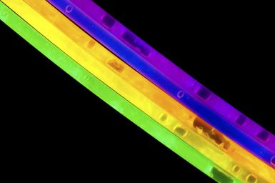 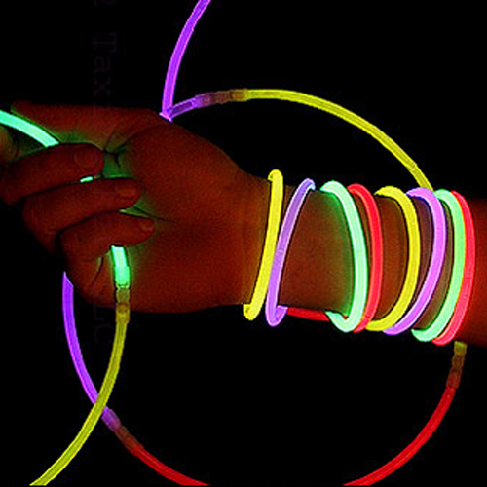

Devise an experiment which would investigate the effect of **temperature** on the chemical reaction in a glowstick.

You should clearly specify:

* Your hypothesis for this investigation (1 mark)
* The independent, dependent and controlled variables in your experiment (2 marks)
* The procedure you would follow (2 marks)
* How you would collect the results and use them to answer the aim of the investigation (2 marks)

1. **(2 marks)**

Magnesium carbonate reacts with aqueous hydrochloric acid according to the reaction

MgCO3(s) + 2HCℓ(aq) 🡪 MgCℓ2(aq) + H2O(ℓ) + CO2(g)

An experiment was conducted to study the rate of this reaction. This was performed using the apparatus shown below.

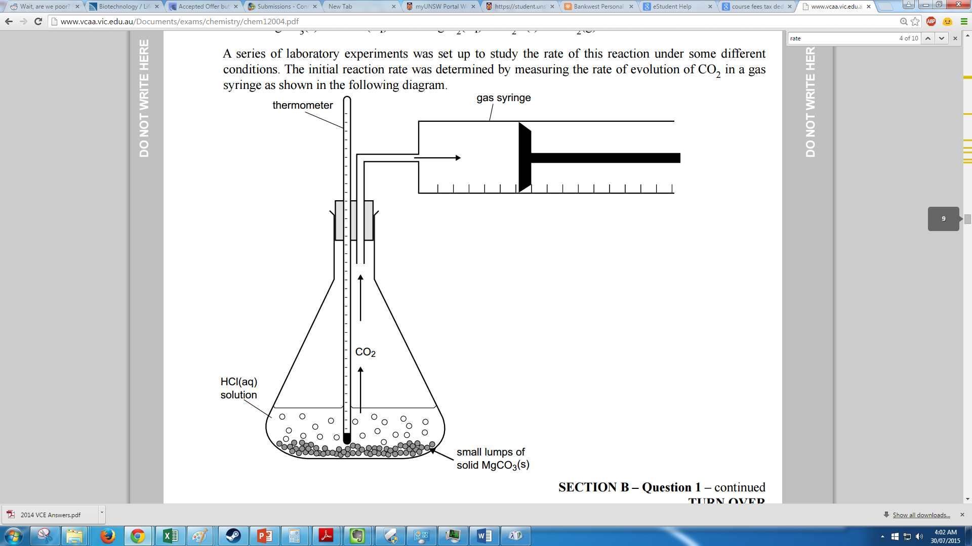

Explain how this apparatus could be used to measure the **rate** of the chemical reaction. (2 marks)

1. **(11 marks)**

In a separate experiment, 40.0 mL of 1.00 mol L‑1 hydrochloric acid was added to 20.0 g of magnesium carbonate chips (a large excess). The flask and contents were immediately weighed and a stop watch started. The mass of the flask and contents were noted as the reaction proceeded. The following table indicates the loss in mass at various times.

|  |  |  |  |  |  |  |  |  |  |  |
| --- | --- | --- | --- | --- | --- | --- | --- | --- | --- | --- |
| Time (min) | 0 | 0.5 | 1.0 | 1.5 | 2.0 | 3.0 | 5.0 | 7.0 | 8.0 | 10.0 |
| Loss in mass (g) | 0 | 0.19 | 0.35 | 0.47 | 0.56 | 0.69 | 0.82 | 0.86 | 0.88 | 0.88 |

1. Plot a graph of ‘loss of mass’ against time on the grid below. (5 marks)

|  |  |  |  |  |  |  |  |  |  |
| --- | --- | --- | --- | --- | --- | --- | --- | --- | --- |
|  |  |  |  |  |  |  |  |  |  |
|  |  |  |  |  |  |  |  |  |  |
|  |  |  |  |  |  |  |  |  |  |
|  |  |  |  |  |  |  |  |  |  |
|  |  |  |  |  |  |  |  |  |  |
|  |  |  |  |  |  |  |  |  |  |
|  |  |  |  |  |  |  |  |  |  |
|  |  |  |  |  |  |  |  |  |  |
|  |  |  |  |  |  |  |  |  |  |
|  |  |  |  |  |  |  |  |  |  |

1. How long did it take for **all** of the acid to get used up? (1 mark)

1. How long did it take for **half** of the acid to get used up? (1 mark)

1. The mass which is lost is due to the loss of carbon dioxide.

i. Calculate the average rate of CO2(g) production in the **first** **five minutes**. Show all working and include appropriate units with your answer. (2 marks)

ii. Calculate the average rate of CO2(g) production in the **last five minutes**. (2 marks)

1. **(2 marks)**

Scientific reports need to be written in a certain style. The method of a scientific report must be written using past-tense and third-person perspective.

Re-write the following method so that it fits the conventions for a scientific report.

***Method:***

The first thing that I would do is to fill two beakers with 50 mL of hydrochloric acid. We would then place a piece of chalk into each beaker of acid at the same time and start the stop watch. Then you need to stir one beaker while the other ones sits on the bench and record the time it takes for the chalk to finish reacting.

1. **(6 marks)**

A student investigated the effect of different catalysts of the enthalpy of the decomposition reaction of hydrogen peroxide. The student’s report is provided below.

**Report: Effect on the different catalysts on the enthalpy of a reaction**

**Background:**

Different catalysts, such as manganese dioxide, MnO2, and iron(III) nitrate solution, Fe(NO3)3, will increase the rate of decomposition of hydrogen peroxide.

2H2O2(aq) 🡪 2H2O(ℓ) + O2(g)

The reaction is exothermic because the enthalpy of the products (ΔHproducts) is less than the enthalpy of the reactants (ΔHreactants).

**Purpose:**

This experiment investigated the effect of using different catalysts on the enthalpy of the decomposition of hydrogen peroxide.

**Procedure:**

The temperature change was measured when MnO2 catalyst was added to a volume of hydrogen peroxide in a beaker. The procedure was repeated using Fe(NO3)3 solution as a catalyst.

**Results:**

|  |  |  |
| --- | --- | --- |
|  | **Trial 1** | **Trial 2** |
| **Volume H2O2** | 100 mL | 200 mL |
| **Concentration H2O2** | 2.0 mol L-1 | 4.0 mol L-1 |
| **Catalyst** | 0.5 g MnO2 | 50 mL 0.1 mol L-1 Fe(NO3)3 |
| **Temperature change** | 3.0 °C | 10.1 °C |

**Conclusion:**

The change in temperature using the Fe(NO3)3 catalyst was greater than the change in temperature using the MnO2 catalyst. This demonstrates that the enthalpy for the decomposition reaction depends on the catalyst used.

The students’ conclusion is not valid because the experimental design is flawed.

Critically review the student’s experimental design. In your response you should:

* Identify and explain **three** improvements or modifications that you would make to the experimental design (3 marks)
* Discuss the experimental outcomes you would **expect** regarding the effect of different catalysts on the heat of reaction. Justify your expectations in terms of chemical ideas you have studied this year and include a relevant diagram. (3 marks)

**SPARE GRAPH**

|  |  |  |  |  |  |  |  |  |  |
| --- | --- | --- | --- | --- | --- | --- | --- | --- | --- |
|  |  |  |  |  |  |  |  |  |  |
|  |  |  |  |  |  |  |  |  |  |
|  |  |  |  |  |  |  |  |  |  |
|  |  |  |  |  |  |  |  |  |  |
|  |  |  |  |  |  |  |  |  |  |
|  |  |  |  |  |  |  |  |  |  |
|  |  |  |  |  |  |  |  |  |  |
|  |  |  |  |  |  |  |  |  |  |
|  |  |  |  |  |  |  |  |  |  |
|  |  |  |  |  |  |  |  |  |  |